How to Setup your own Simple Personal Private Cloud: ownCloud

1. Install VirtualBox
2. <https://www.virtualbox.org/wiki/Downloads>
3. Install Ubuntu Server 16.0.4.4 LTS (in Windows)
4. <https://www.ubuntu.com/download/server>
5. Create a new Virtual Machine in Oracle VirtualBox
   1. 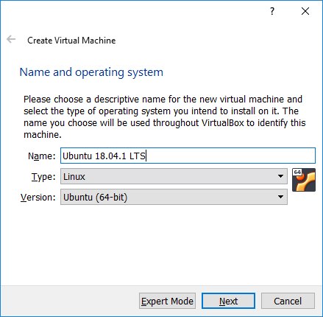
   2. 1024 MB memory
   3. Create a virtual hard disk now (10GB)
   4. Hard disk file type: VDI (VirtualBox Disk Image)
   5. Storage on physical hard disk dynamically allocated (only use space as it fills up, up to maximum fixed size (will not auto shrink when space freed)
   6. 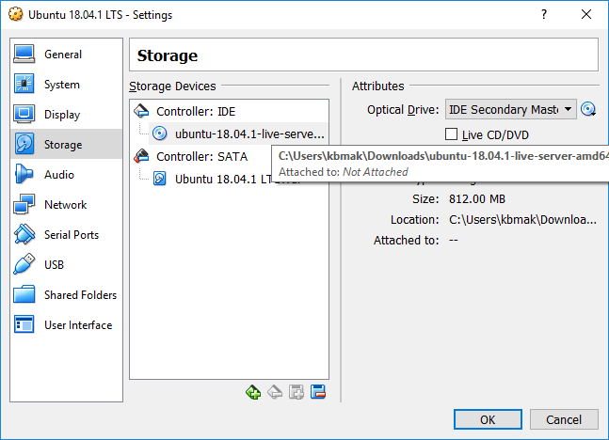
   7. Disable Audio

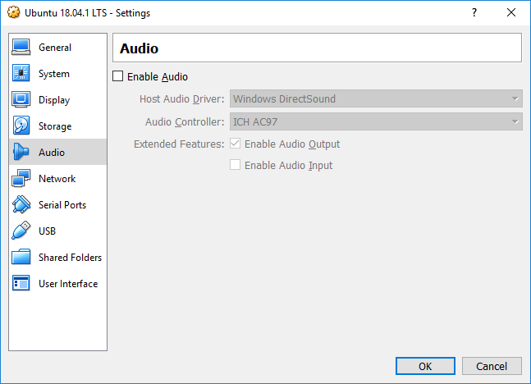

* 1. 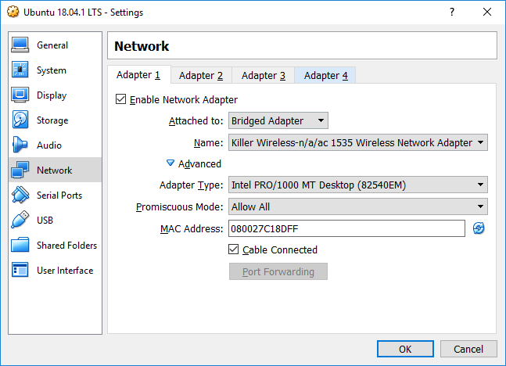

1. Install Ubuntu Server
   1. 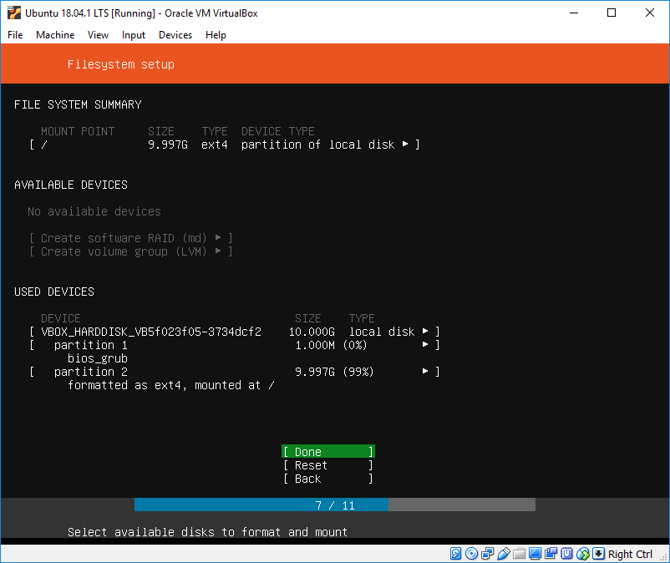
   2. 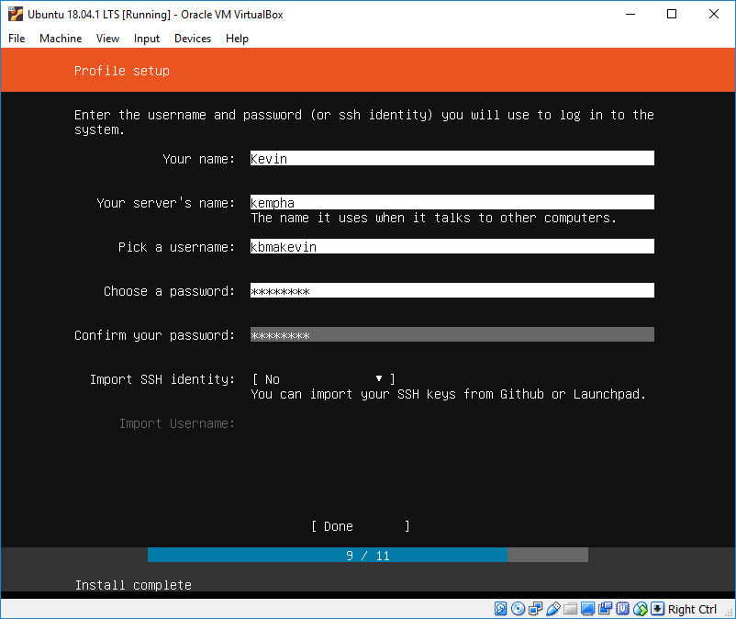
   3. 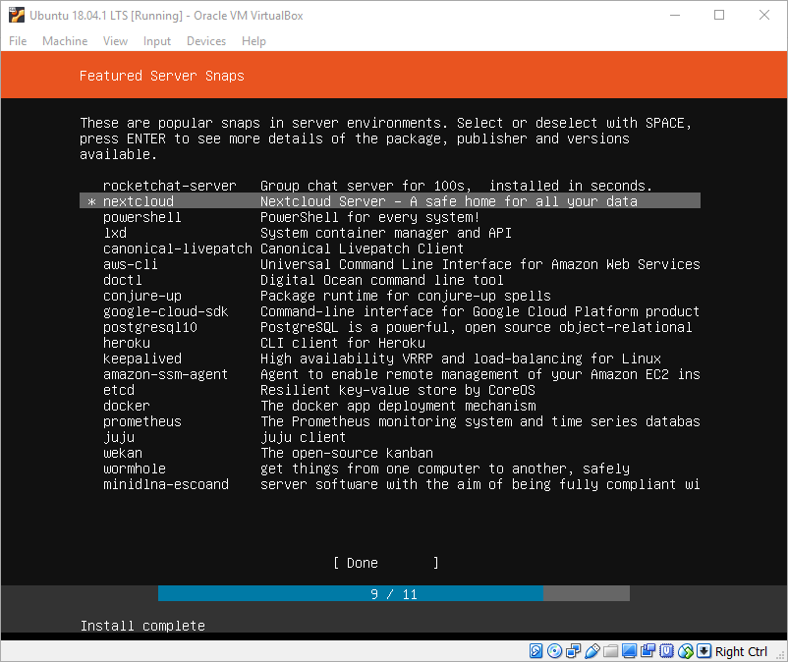
2. Go to the ip address of your ubuntu server in your favorite browser to create an admin account to finalize the nextcloud setup.
3. 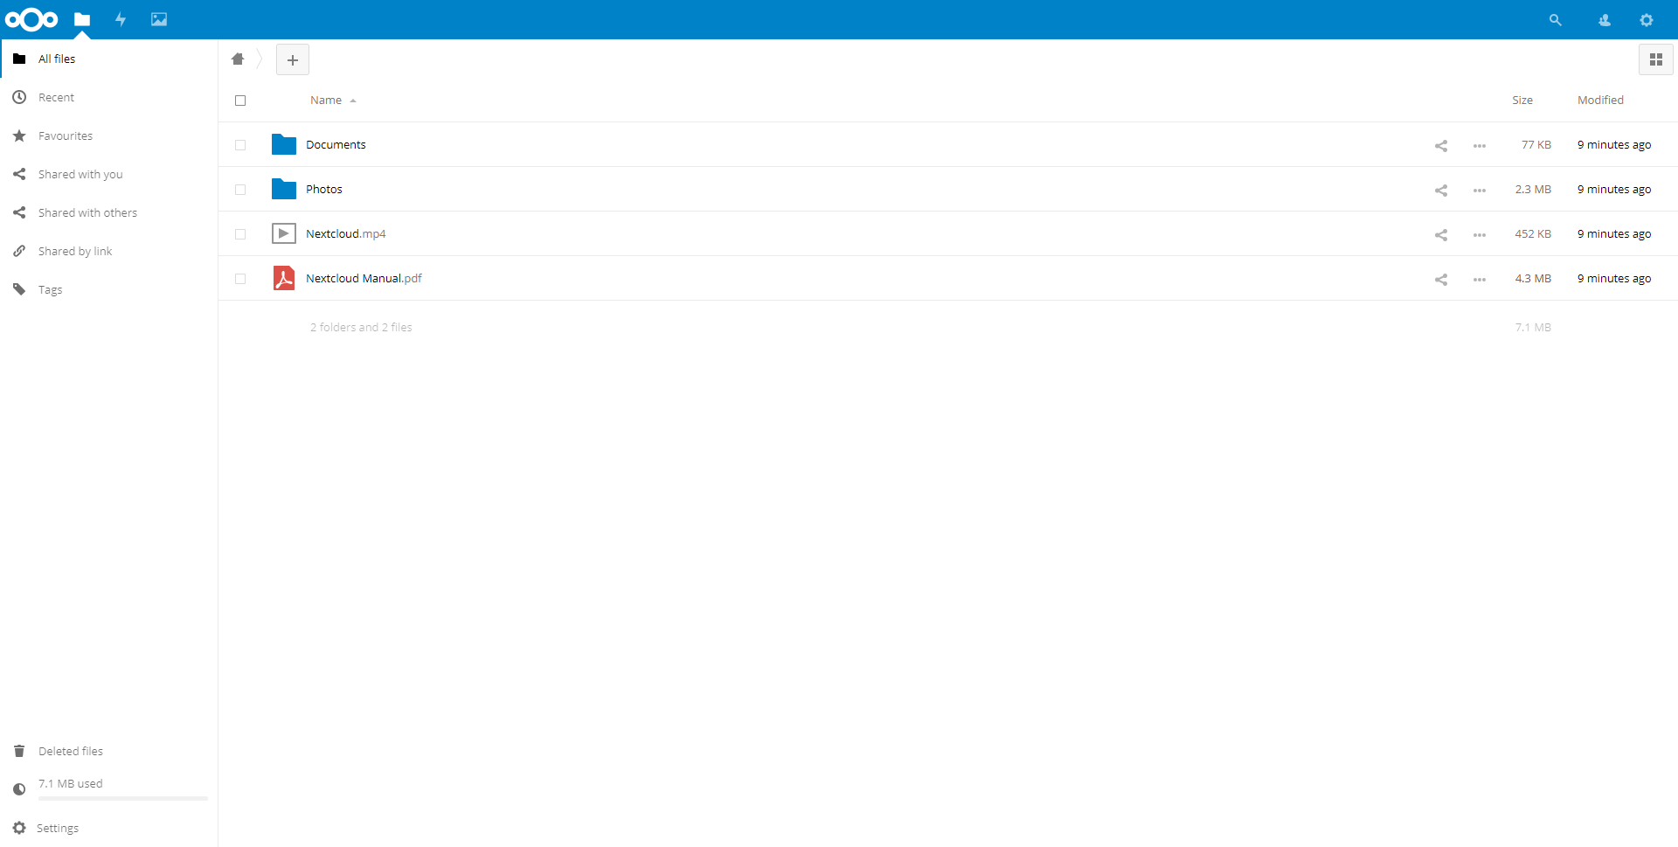
4. Install nextCloud clients (Desktop, Mobile)
5. 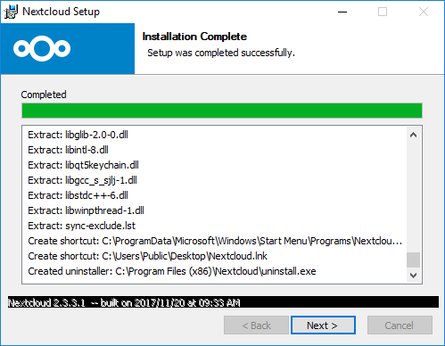
6. 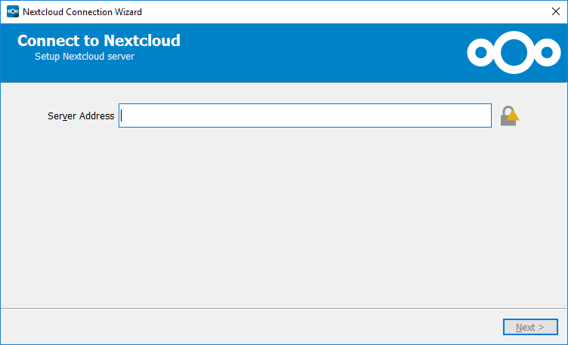
7. 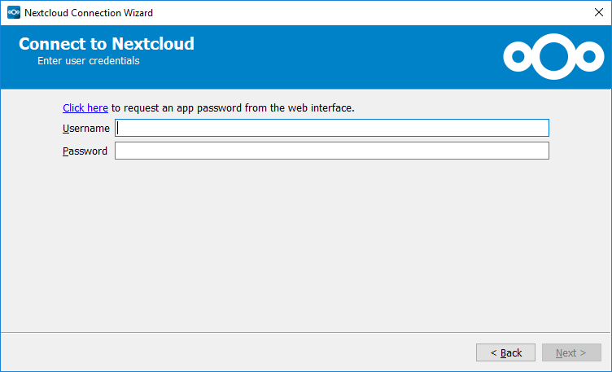
8. 